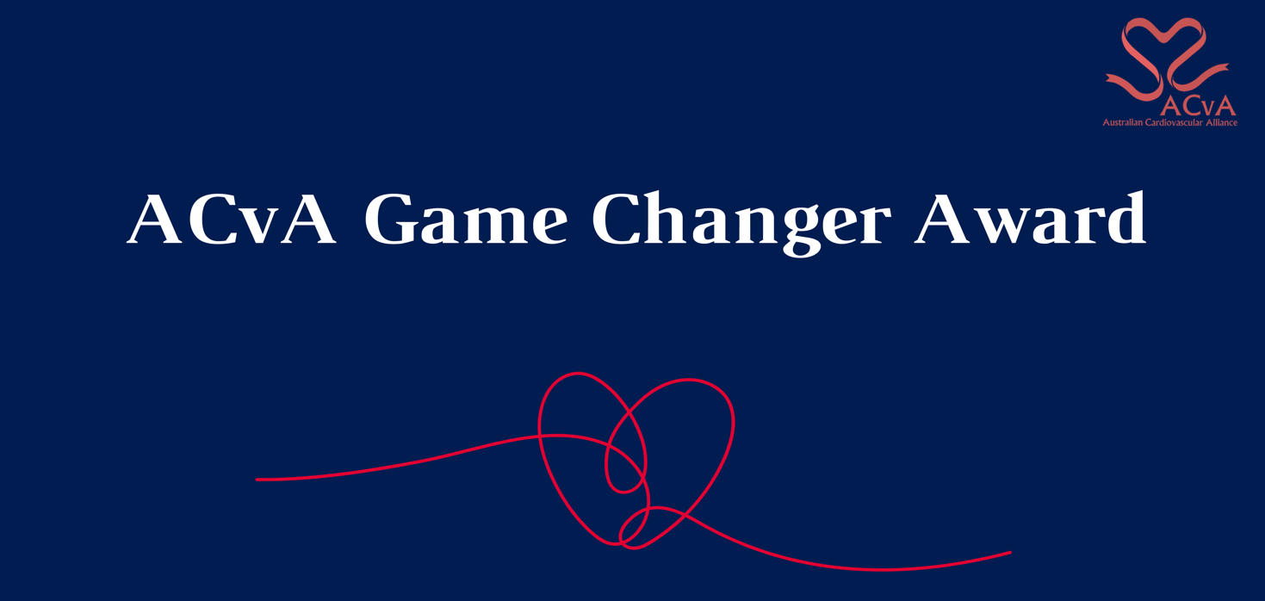

The ACvA Game Changer Award is for an idea, procedure or finding that has the potential to significantly shift the current thoughts and practices in cardiovascular disease and stroke research.

By way of example, it could be:

* an early stage finding
* bringing new methods, technologies or techniques together to create a new way of doing things
* bringing fields of research together potentially creating a whole new field of inquiry
* an idea that creates positive ripples/disruption in the research/medical field to which it applies and more broadly.

# Eligibility criteria and conditions

* This award has a strong focus on contemporary ideas/innovations with the program of work being current in the past 24 months.
* The nominee can be any researcher or a team of researchers, irrespective of discipline but needs to have relevance to improving cardiovascular and stroke health outcomes, whether in the short, medium or long term.
* Early-mid career researchers (EMCRs; 15 years < post-PhD) are strongly encouraged to apply.
* The nominee does NOT have to be an ACvA member.

Conditions

* By submitting this application, the nominee agrees to the use of any of the following for promotional purposes: profile picture, bio details, quotes from all sections of the application.
* The nominee agrees to participate in promotional activities related to the ACvA Excellence in Cardiovascular Research Awards should they be required.

# How to nominate

* Complete the nomination form below. The Game Changer Award can be nominated by anyone, including by themselves.
* The nominator/nominee should complete the attached template, noting the requirement for two referees to provide objective evidence of the impact of their work. These can include:
  + Peers
  + Senior scientists/lab heads/research directors
  + Funding bodies (eg NHFA, Stroke Foundation)
  + Industry
  + Government
  + Editors from journals
  + Consumers
* At least one referee must be from an external organisation.

# Nomination assessment

* The key criteria will be demonstrating that the idea, procedure or finding will have the potential to significantly impact the current thoughts and practices in cardiovascular disease and stroke research.
* Nominations will provided to a review panel who will select the award based on the nominees work over the past 24 months.

**COMPLETE THE NOMINATION SUBMISSION FORM (NEXT PAGE)**

# Application Form

# Terms and Conditions

|  |  |
| --- | --- |
| For promotional purposes, do you give permission for your name to be displayed alongside any referee/mentee quotes? | □ Yes, I/my referees give permission to display our names together with any quotes□ No, I/my referees would like to remain anonymous |
| By submitting this application the nominee agrees or permission has been granted by the nominee to use any of the following for promotional purposes: profile picture, bio details, quotes from all sections of the application. | □ Yes I agree |
| Please attach a profile picture as part of your submission. | □ Yes I have attached a profile picture along with my application. |
| Please include a short professional bio (200 words max.) |  |

# Nominee Details

|  |  |  |  |
| --- | --- | --- | --- |
| This award nomination is for (Please tick one): | **□** Someone else  **□** My team  **□** Myself | | |
| Title |  | | |
| First Name |  | | |
| Last Name |  | | |
| Current appointment |  | | |
| Current institution |  | | |
| Preferred contact number |  | Email |  |
| Communication/publicity contact for you organisation | (Name + email) | | |
| If you are nominating as part of a team, please list all members and their organisations. | *Please list members and their organisations.* | | |

**Award details**

|  |  |
| --- | --- |
| Briefly summarise the research being conducted (200 words max) |  |
| What makes it a game changer? What is new in your approach? (300 words max) |  |
| What difference will it make? (200 words max) |  |

**Referees**

**Referee 1 details**

|  |  |  |  |
| --- | --- | --- | --- |
| Title |  | | |
| First Name |  | | |
| Last Name |  | | |
| Current appointment and institution |  | | |
| Preferred contact number |  | Email |  |
| Reference  [Briefly describe why this work is innovative/ transformative, including its impact to the field] 300 words max. |  | | |

# External Referee details

# *Must not be from the same organisation as the nominee.*

|  |  |  |  |
| --- | --- | --- | --- |
| Title |  | | |
| First Name |  | | |
| Last Name |  | | |
| Current appointment and institution |  | | |
| Preferred contact number |  | Email |  |
| Reference  [Briefly describe why this work is innovative/ transformative, including its impact to the field] 300 words max. |  | | |